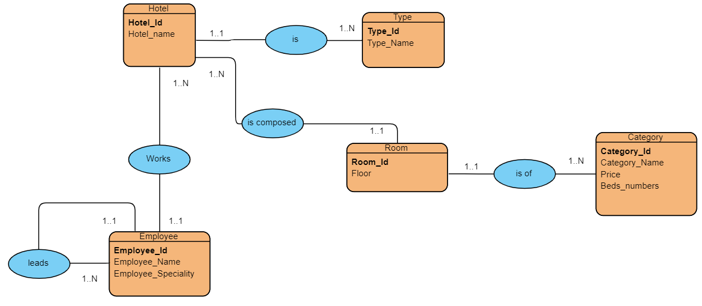

Hotel(Hotel_id , Hotel_name,#Type_Id)

Type(Type_Id,Type_name)

Room(Room_Id,Floor,#Hotel_Id,#Category_Id)

Category(Category_Id,Category_Name,Price,Beds_numbers)

Employee(Employee_Id , Employee_name,Employee_speciality,#Hotel_Id)